Wokingham borough council  HOUSING SERVICE

**Tenant satisfaction measures report: 2023**



# **Accessibility and Translation**

|  |  |  |  |  |  |  |  |
| --- | --- | --- | --- | --- | --- | --- | --- |
| English | Arabic | Hindi | Punjabi | Telugu | Urdu | Chinese Mandarin | Polish |
| Copies of this policy may be obtained in large print, Braille, on audio cassette or in other languages. To obtain a copy in an alternative format please telephone 0118 974 6000. | تتوفر نسخٌ من هذه السياسة في طبعات كبيرة أو بطريقة بريل أو على شرائط صوتية أو بلغات أخرى. وللحصول على نسخة بأحد التنسيقات البديلة، يرجى الاتصال بنا على رقم  الهاتف:.  0118 974 6000 | इस नीति की प्रतिलिपियां बड़े प्रिंट में, ब्रेल में, ऑडियो कैसेट के रूप में या अन्य भाषाओं में प्राप्त की जा सकती हैं। वैकल्पिक प्रारूप में प्रतिलिपि पाने के लिए, कृपया 0118 974 6000 पर फोन करें। | ਇਸ ਨੀਤੀ ਦੀਆਂ ਕਾਪੀਆਂ ਵੱਡੇ ਅੱਖਰਾਂ ਵਿੱਚ, ਬ੍ਰੇਲ ਵਿੱਚ, ਆਡੀਓ ਕੈਸੇਟ 'ਤੇ ਜਾਂ ਹੋਰ ਭਾਸ਼ਾਵਾਂ ਵਿੱਚ ਪ੍ਰਾਪਤ ਕੀਤੀਆਂ ਜਾ ਸਕਦੀਆਂ ਹਨ। ਕਿਸੇ ਵਿਕਲਪਿਕ ਫਾਰਮੈਟ ਵਿੱਚ ਇੱਕ ਕਾਪੀ ਪ੍ਰਾਪਤ ਕਰਨ ਲਈ ਕਿਰਪਾ ਕਰਕੇ 0118 974 6000 'ਤੇ ਟੈਲੀਫੋਨ ਕਰੋ। | ఈ పాలసీ కాపీలను పెద్ద ప్రింట్‌‌లో, బ్రెయిలీలో, ఆడియో క్యాసెట్‌లో లేదా ఇతర భాషలలో పొందవచ్చు. ప్రత్యామ్నాయ ఫార్మాట్‌లో పొందడానికి దయచేసి 0118 974 6000 కు టెలీఫోను చేయండి. | اس پالیسی کی نقلیں بڑے حروف، بریل، آڈیو کیسٹ کی صورت میں یا دیگر زبانوں میں بھی حاصل کی جا سکتی ہیں۔ متبادل فارمیٹ میں نقل حاصل کرنے کے لیے برائے مہربانی 0118 974 6000 پر ٹیلیفون کریں۔ | 本政策副本能以大字版、盲文版、录音带或其他语言的形式提供。如需获取其他格式副本，请致电 0118 974 6000。 | Egzemplarze tej polityki są dostępne w wersji z dużą czcionką, w języku Braille’a, na kasetach magnetofonowych lub w innych językach. Aby otrzymać egzemplarz w innym formacie, należy zadzwonić pod numer 0118 974 6000. |

This is a script version of the TSM report including detailed descriptions of all graphs. If you or somebody you know needs this report in a different language or more accessible format, please contact [HousingMedia@wokingham.gov.uk](mailto:HousingMedia@wokingham.gov.uk).

# **Tenant Satisfaction Measures (TSM) 2023**

Results Report | Produced by Jinder Reyatt and Jay Rumboldt

**Contents**

**Accessibility and Translation** 1

**Tenant Satisfaction Measures (TSM) 2023** 2

**Opening Statement** 3

01. National and Regional Satisfaction 4

**National Satisfaction** 4

**Local Satisfaction - Wokingham** 6

**Tenant Perception TSMs from STAR Survey 2023** 6

**Management TSM Results for 2023-24 Financial Year** 7

02. Overall Satisfaction 7

03. Perceptions 9

**Perceptions: Yearly Comparison** 10

04. Priorities 12

05. Value for Money 13

06. Health and Safety 14

07. Advice and Support 16

**Advice and Support Overview:** 17

**Advice on claiming benefits.** 17

**Advice on managing finances and paying rent.** 18

**Support for vulnerable tenants.** 20

08. Contacts and communication 21

09. Neighbourhood 22

10. Lettings 23

11. Responsive Repairs 27

12. Anti-Social Behaviour (ASB) 31

**Overview of ASB:** 32

13. Complaints 33

14. Communal Buildings 35

15. Sheltered Housing 37

16. Concluding Statement 40

17. Appendix 1: Housemark end of year national Tenant Satisfaction Measures (TSM) data. 40

18. Appendix 2: Summary of Approach 43

**This report contains analysis of the Tenant Satisfaction Measures and our results from the STAR Survey conducted in November 2023. This survey will be conducted yearly in accordance with the Housing Regulatory Standards.**

## **Opening Statement**

**It has been a challenging few years for everyone.** Since the last survey, the housing industry and national culture have changed: factors such as Brexit, COVID, the Cost-of-Living crisis, and inflation being at its highest point in many years have put pressure on the Housing Service, leading to increasingly stretched resources and financial pressures. This has made an impact on satisfaction scores across the country for housing providers.

The STAR Survey is a perception-based survey, meaning it takes into consideration how tenants feel about the Housing Service. Economic factors such as the Cost-of-Living Crisis, and social factors such as the COVID-19 pandemic, have affected how positively people feel about their lives and the places they live, which may impact satisfaction levels. The recent national press around housing has had many negative connotations towards social housing landlords, particularly in light of the Grenfell disaster and serious damp and mould concerns.

This report contains two appendices, the **first** of which compares Wokingham Borough Council’s STAR Survey results against housing providers nationally. The **second** is our **summary of approach** for conducting the survey.

## National and Regional Satisfaction

### **National Satisfaction**

Figure 1, taken from Housemark’s 23/24 end of year TSM report, shows that **overall satisfaction has fallen across the United Kingdom**.

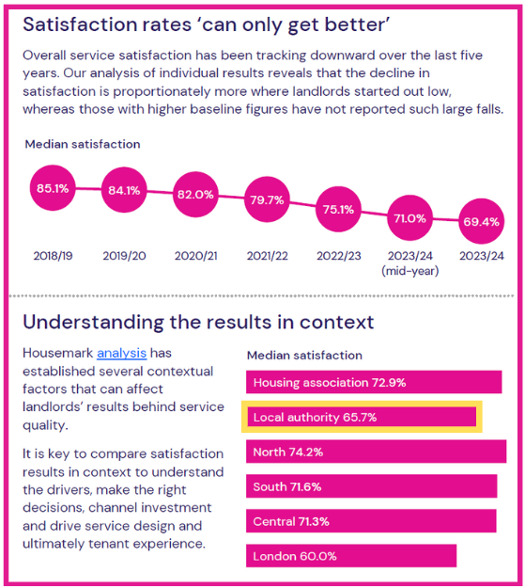

**Figure 1**: Segment from Housemark’s end of year Tenant Satisfaction Measure report for the 2023/2024 financial year. Segment reads:

“**Satisfaction rates can ‘only get better’.** Overall service satisfaction has been tracking downward over the last five years. Our analysis of individual results reveals that the decline in satisfaction is proportionately more where landlords started out low, whereas those with higher baseline figures have not reported such large falls.

**Median Satisfaction:** 85.1% in 2018/2019; 84.1% in 2019/2020; 82.0% in 2020/2021; 79.7% in 2021/2022; 75.1% in 2022/2023; 71.0% in 2023/2024 (mid-year); and 69.4% at the end of 2023/2024.

**Median satisfaction [per landlord type, end of 2023/2024]:**

* Housing association: 72.9%
* Local authority: 65.7%
* North [of UK]: 74.2%
* South [of UK]: 71.6%
* Central [UK]: 71.3%
* London: 60.0%

**Understanding the results in context:**

Housemark analysis has established several contextual factors that can affect landlords’ results behind service quality.

It is key to compare satisfaction results in context to understand the drivers, make the right decisions, channel investment and drive service design and ultimately tenant experience.” (Housemark, 2024)

* The overall satisfaction score in the Wokingham Borough Council STAR Survey 2023 was 81%.
* The average for local authorities in the UK was 65.7%, meaning we scored around 15% above the sector average.
* Overall satisfaction for social landlords in the UK dropped hugely following the COVID-19 pandemic and is also suffering from the Cost-of-Living crisis.
* Housemark predicts that tenants’ perceptions of their landlords may not recover to 2010 levels until the latter part of this decade.

**In light of all these national challenges, Wokingham overall is performing well with some areas for further improvement.**

In order to continue to improve our services, with the results of our STAR Survey, the Housing Service is implementing a Housing Improvement Programme led by our senior management team which covers the breadth of the service, including how we can better utilise information technology, improving the safety of our stock, and developing our neighbourhoods.

We have already begun this work. For example, a specialist consultancy has been recruited to improve the management and safety of our stock.

We are also assessing ourselves against new regulations that have come into force, including the updated Consumer Standards and the Housing Ombudsman’s Complaints Handling Code. This will help us to see what we need to do to ensure we are working towards becoming a best practice provider.

**Appendix 1** at the end of this report is a list of the National TSM Perception results from Housemark’s Tenant Satisfaction Measures 2023/24 end of year report.

### **Local Satisfaction - Wokingham**

Below is a list of Wokingham Borough Council’s Tenant Satisfaction Measures for the 2023/24 financial year. The Regulator of Social Housing introduced a total of **22 Tenant Satisfaction Measures (TSMs)**. 12 of these are **‘tenant perception’ (TP) measures**, which have been collected through the STAR Survey. The remaining 10 measures are collected through the **management information** we routinely compile for our performance monitoring.

### **Tenant Perception TSMs from STAR Survey 2023**

* TP01: Overall satisfaction – 81.0%
* TP02: Satisfaction with repairs – 82.1%
* TP03: Satisfaction with time taken to complete most recent repair – 82.2%
* TP04: Satisfaction that the home is well-maintained – 81.4%
* TP05: Satisfaction that the home is safe – 85.4%
* TP06: Satisfaction that the landlord listens to tenant views and acts upon them – 63.6%
* TP07: Satisfaction that the landlord keeps tenants informed about things that matter to them – 66.7%
* TP08: Agreement that the landlord treats tenants fairly and with respect – 69.5%
* TP09: Satisfaction with the landlord’s approach to handling of complaints – 47.8%
* TP10: Satisfaction that the landlord keeps communal areas clean and well-maintained – 69.1%
* TP11: Satisfaction that the landlord makes a positive contribution to neighbourhoods – 47.5%
* TP12: Satisfaction with the landlord’s approach to handling anti-social behaviour – 28.4%

### **Management TSM Results for 2023-24 Financial Year**

* RP01: Proportion of homes that do not meet the Decent Homes Standard – 0.8%.
* RP02: Repairs completed within target timescale:
  + Proportion of non-emergency responsive repairs completed within the landlord’s target time scale – 85.2%.
  + Proportion of emergency responsive repairs completed within the landlord’s target time scale – 100.0%.
* BS01: Gas safety checks – 100.0%
* BS02: Fire safety checks – 100.0%
* BS03: Asbestos safety checks – 100.0%
* BS04: Water safety checks – 100.0%
* BS05: Lift safety checks – 99.1%
* CH01: Complaints relative to the size of the landlord:
  + Stage 1 complaints – 39.1 per 1,000 properties.
  + Stage 2 complaints – 13.8 per 1,000 properties.
* CH02: Complaints responded to within Complaint Handling Code timescales:
  + Stage 1 complaints – 73.7.
  + Stage 2 complaints – 48.5.
* NM01 (1): Number of anti-social behaviour cases opened per 1,000 homes – 49.3.
* NM01 (2): Number of anti-social behaviour cases that involved hate incidents opened per 1,000 homes – 0.0.

For more information about the TSMs and the Regulator of Social Housing, visit the government website here: <https://www.gov.uk/government/consultations/consultation-on-the-introduction-of-tenant-satisfaction-measures/outcome/tenant-satisfaction-measures-summary-of-rsh-requirements-accessible>

## Overall Satisfaction

**It has been a challenging few years for everyone.** Since the last STAR Survey in 2020, we have seen the COVID-19 outbreak and the start of a Cost-of-Living crisis, raising awareness of social housing issues among tenants whilst increasing expectations. This has undoubtedly made an impact on satisfaction scores across the country.

**Figure 2**: Line graph titled “Overall Satisfaction: Percentage of respondents satisfied with the overall service provided by Wokingham Borough Council’s Housing Service”. The graph includes data from every STAR Survey since 2012, spanning from 2012 to 2023. The results read as follows: 2012 at 83%; 2014 at 84%; 2016 at 87%; 2018 at 90%; 2020 at 88%; 2023 at 81%.

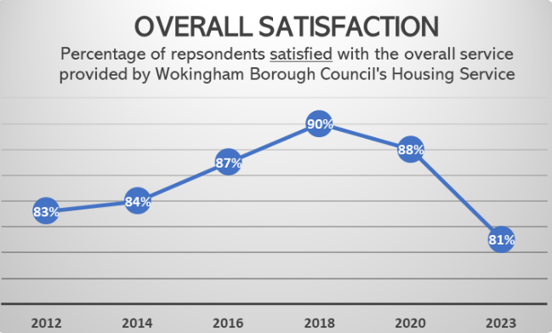

**The national average satisfaction score for social housing has decreased since 2020, and we are no different.** Since the STAR Survey in 2020, overall satisfaction has **decreased by 7%**. Whilst we have seen a decrease in overall satisfaction, the service remains **well above the national average for Local Authorities**.

**Figure 3**: Pie chart showing the percentage of tenants in the STAR Survey 2023 who were either very satisfied or fairly satisfied, very dissatisfied or fairly dissatisfied, or neither satisfied nor dissatisfied with the overall service provided by the Housing Service. The results show that 81% of respondents were either very satisfied or fairly satisfied, 6% were very dissatisfied or fairly dissatisfied, and 13% were Neither Satisfied nor Dissatisfied.

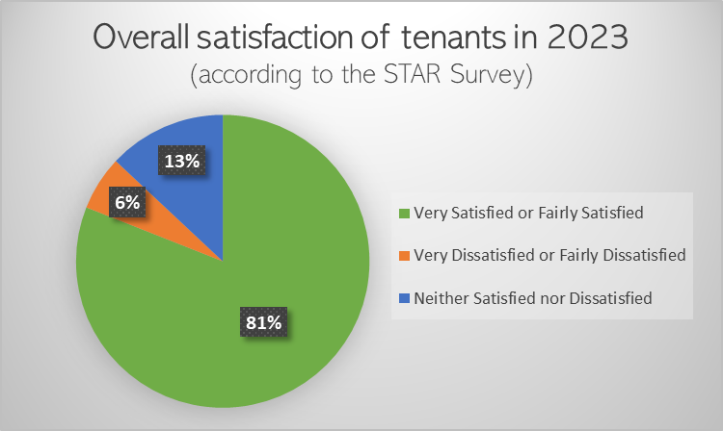

Although we have seen a decrease in satisfaction levels, the data shows that dissatisfaction levels have remained consistent with the previous years. Throughout the survey we have seen a considerable rise in people selecting **neither satisfied nor dissatisfied**, having a knock-on effect on satisfaction levels as a result. This is a common theme throughout the results.

## Perceptions

As highlighted in previous editions of Housing Matters, the Regulator of Social Housing has introduced a new set of Tenant Satisfaction Measures (TSMs). As part of the new regulations, we are required to submit the results of these questions (as well as the other TSMs) to the Regulator. The following results show how we are currently performing in line with these.

**For the majority of this section, around a quarter of tenants responded with “Neither” or “Not Applicable/Don’t Know”. This tells us that we need to be doing more to keep tenants informed on Housing Service updates and plans. Overall, satisfaction for the perception questions is positive.** Going forward, the ways in which we share news, Housing Service updates, and performance info with you will be increasing. As well as our quarterly **Housing Matters** magazine, **social media and in-person events** will be a regular part of our tenant engagement.

**Figure 4**: Pie chart showing respondents satisfaction with the statement: “The Housing Service **listens to my views and acts upon them**.” The data shows that 62% of respondents were very satisfied or fairly satisfied, 12% were very dissatisfied or fairly dissatisfied, 23% responded neither satisfied nor dissatisfied, and 3% responded ‘not applicable or don’t know’.

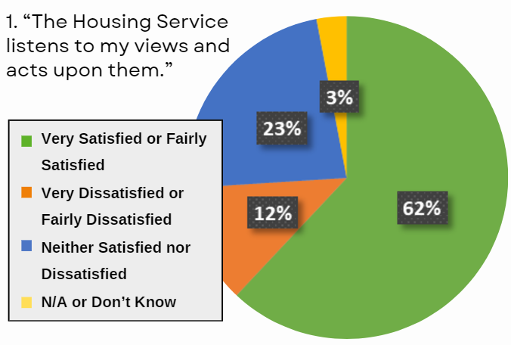

**Figure 5**: Pie chart showing respondents satisfaction with the statement: “The Housing Service **keeps you informed** about things that matter to you.” The chart shows that 67% of respondents were very satisfied or fairly satisfied, 10% were very dissatisfied or fairly dissatisfied, 21% responded neither satisfied nor dissatisfied, and 2% responded ‘not applicable or don’t know’.

**Figure 6**: Pie chart showing respondents satisfaction with the statement: “The Housing Service **treats its residents fairly and with respect**.” In response to this statement, 70% of respondents said they agreed or strongly agreed, 6% disagreed or strongly disagreed, 22% responded ‘neither agree nor disagree’, and 2% responded ‘not applicable or don’t know’.

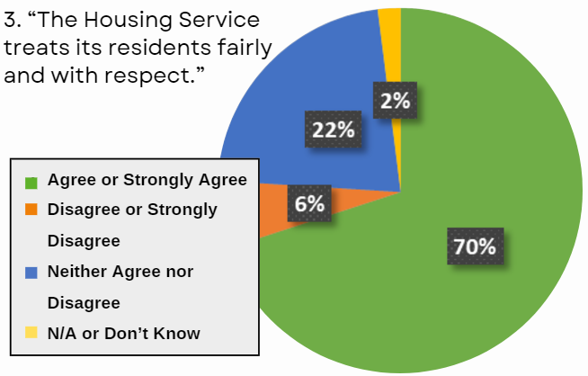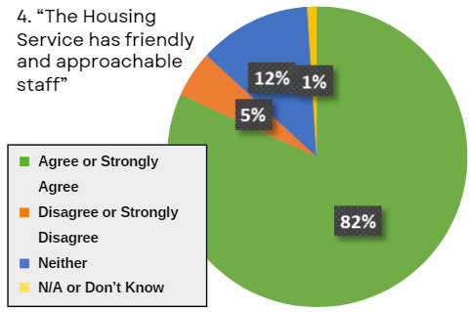

**Figure 7**: Pie chart showing respondents satisfaction with the statement: “The Housing Service has **friendly and approachable staff**”. In response to this, 82% of respondents agreed or strongly agreed, 5% disagreed or strongly disagreed, 12% responded ‘neither’, and 1% responded ‘not applicable or don’t know’.

* The **increase in “Neither or N/A” responses** has led to a decrease in satisfaction.
* However, **the number of tenants dissatisfied is low**.
* We **intend to increase our channels of communication**, including more digital avenues and in-person engagement events.
* We will also **improve the transparency and visibility of our services**, giving tenants the opportunity to scrutinise and ask questions through our involved tenant groups.
* We intend to **undertake more surveying** of our tenants to better understand the things that matter most to you and do our best to implement them if possible.

### **Perceptions: Yearly Comparison**

We are developing a **new set of Service Standards** to better highlight what tenants can expect of us, managing expectations by being clear on what we can deliver. These new Service Standards will be consulted on with our tenant volunteers to ensure they are robust, fair, and meet tenant needs.

**Figure 8**: Line graph plotting the yearly satisfaction levels in response to the question: “The Housing Service **listens to your views and acts upon them**”. The three lines plotted on the graph represent the percentage of tenants who were satisfied, dissatisfied, and Neither Satisfied nor Dissatisfied.

* **For “Satisfied”:** 2012 at 67%, 2014 at 69%, 2016 at 72%, 2018 at 76%, 2020 at 78%, and 2023 at 62%.
* **For “Dissatisfied”:** 2012 at 17%, 2014 also at 17%, 2016 at 16%, 2018 at 15%, 2020 at 13%, and 2023 at 26%.
* **For “Neither or Not Applicable”:** 2012 at 16%, 2014 at 14%, 2016 at 12%, 2018 at 10%, 2020 also at 10%, and 2023 at 12%.

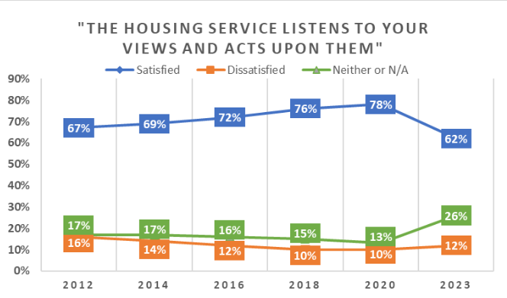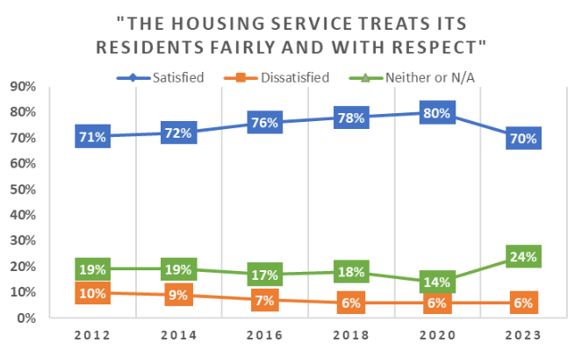

**Figure 9**: Line graph plotting the yearly satisfaction levels in response to the question: “The Housing Service **treats its residents fairly and with respect**”. Again, the three lines plotted on the graph represent the percentage of tenants who were satisfied, dissatisfied, and Neither Satisfied nor Dissatisfied.

* **For “Satisfied”:** the results read as follows: 2012 at 71%, 2014 at 72%, 2016 at 76%, 2018 at 78%, 2020 at 80%, and 2023 at 70%.
* **For “Dissatisfied”:** 2012 was at 19%, 2014 was also at 19%, 2016 at 17%, 2018 at 18%, 2020 at 14%, 2023 at 24%.
* **For “Neither or Not Applicable”:** 2012 was at 10%, 2014 at 9%, 2016 at 7%, 2018 at 6%, 2020 also at 6%, and 2023 also at 6%.

**Figure 10**: Line graph plotting the yearly satisfaction levels in response to the question: “The Housing Service **has friendly and approachable staff**”. As with Figures 7 and 8, the three lines plotted on the graph represent the percentage of tenants who were satisfied, dissatisfied, and Neither Satisfied nor Dissatisfied.

* **For “Satisfied”:** 2012 was at 80%, 2014 at 81%, 2016 at 84%, 2018 at 85%, 2020 also at 85%, and 2023 at 81%.
* **For “Dissatisfied”:** 2012 was at 15%, 2014 was also at 15%, 2016 was at 12%, 2018 at 13%, 2020 at 12%, and 2023 at 13%.
* **For “Not Applicable or Don’t Know”:** 2012 at 5%, 2014 at 4%, 2016 also at 4%, 2018 at 3%, 2020 at 6%, and 2023 at 5%.

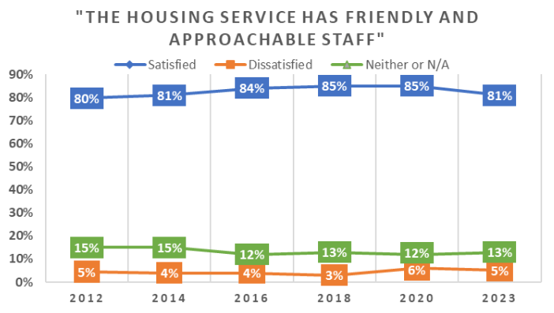

## Priorities

We asked which areas of the service were most important for you out of the options provided. **Here is what you told us...**

1. Repairs and Maintenance.
2. The overall quality of your home.
3. Keeping you informed.

* **Repairs and Maintenance** has consistently been tenants’ number one priority of the service.
* This has **remained the same across all STAR Surveys** since 2012.
* The **overall quality of your home** goes hand-in-hand with the Repairs and Maintenance service, so it is no surprise to see this place 2nd.
* The need to be **kept informed** is a theme throughout the STAR 2023 results, showing that we need to focus heavily on improving the ways in which we communicate with tenants.

## Value for Money

With the added pressures of the Cost-of-Living crisis, it is important that you feel your rent offers good value for money. Given the financial stress that so many people are facing, it is not surprising that we have seen **a slight drop in satisfaction** for the value of rent. Let’s take a closer look.

* There has been a **slight decrease** in satisfaction levels, **by 1%**, but this still remains above 80%.
* Sheltered tenants feel they are getting more value for money on their rent than General Needs (around 80% and 88% respectively).
* However, **dissatisfaction has also dropped by 2%** from the previous survey (from 9% to 7%) as highlighted in the line graph below.
* There has been a **5% increase** in tenants selecting the **Neither Satisfied nor Dissatisfied** option.

**Figure 11**: Pie chart showing satisfaction with the statement: “Your rent provides good value for money”. The chart shows that 84% of respondents were satisfied or very satisfied with this statement, 7% were dissatisfied or very dissatisfied, and 9% were Neither Satisfied nor Dissatisfied.

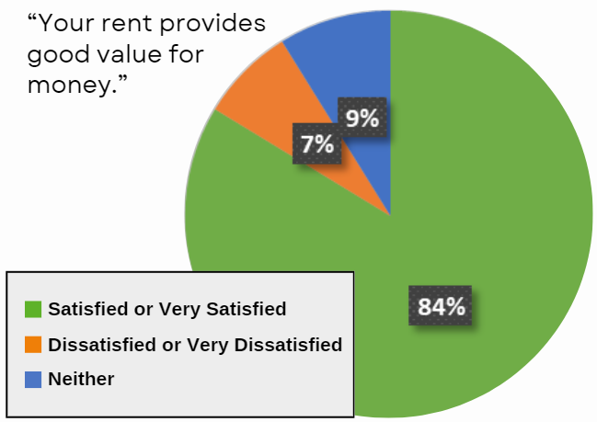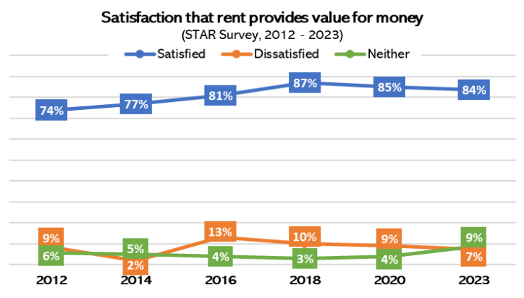

**Figure 12**: Line graph showing the percentage of respondents satisfied, dissatisfied, or Neither Satisfied nor Dissatisfied with the statement: “Your rent provides good value for money”. This graph spans from 2012 to 2023.

* **For “Satisfied”:** 2012 was at 74%, 2014 at 77%, 2016 at 81%, 2018 at 87%, 2020 at 85%, and 2023 at 84%.
* **For “Dissatisfied”:** 2012 was at 9%, 2014 was at 2%, 2016 at 13%, 2018 at 10%, 2020 at 9%, and 2023 at 7%.
* **For “Neither”:** 2012 was at 6%, 2014 was at 5%, 2016 at 4%, 2018 at 3%, 2020 at 4%, and 2023 at 9%.

**Figure 13**: Bar graph titled: “Level of satisfaction that rent provides value for money: STAR Survey 2023. (Breakdown between General Needs and Sheltered)”. This chart is split into three sections: General Needs, Sheltered, and Overall satisfaction.

* **For General Needs tenants:** 79.7% were satisfied or very satisfied with the statement, 8.7% were dissatisfied or very dissatisfied, and 11.5% were Neither Satisfied nor Dissatisfied.
* **For Sheltered tenants:** 87.7% were satisfied or very satisfied, 6.2% were dissatisfied or very dissatisfied, and another 6.2% were Neither Satisfied nor Dissatisfied.
* **Across all tenancy types:** 83.7% were satisfied or very satisfied that rent provides value for money, 7.5% were dissatisfied or very dissatisfied, and 8.9% were Neither Satisfied nor Dissatisfied.

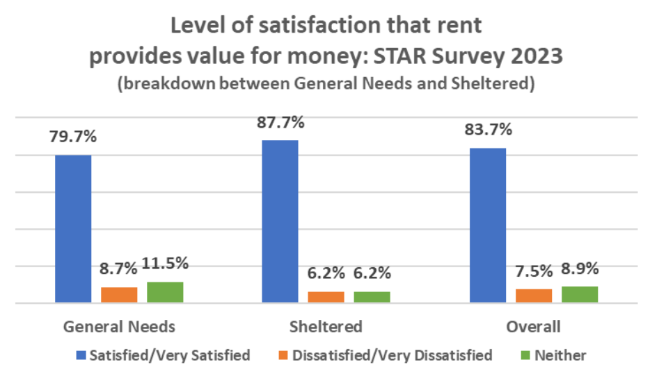

## Health and Safety

As highlighted by tenants’ chosen priorities in Section 3, **the safety of our homes is paramount**. This includes keeping all our properties in good repair, as well as ensuring we are compliant to new legislation including the Consumer Standards and the Building Safety Regulations.

**Figure 14**: Bar graph titled “Responses to the statement: ‘The Housing Service provides a home that is safe.’”. This graph spans from 2012 to 2023 and shows the percentage of respondents who were very satisfied or fairly satisfied, very satisfied or fairly dissatisfied, or Neither Satisfied nor Dissatisfied toward the statement.

* **For Very Satisfied or Fairly Satisfied**: 2012 was at 80%, 2014 at 84%, 2016 at 85%, 2018 at 91%, 2020 at 89%, and 2023 at 86%.
* **For Very Dissatisfied or Fairly Dissatisfied**: 2012 was at 15%, 2014 at 11%, 2016 also at 11%, 2018 at 7%, 2020 also at 7%, and 2023 at 8%.
* **For Neither Satisfied nor Dissatisfied**: 2012 was at 6%, 2014 at 5%, 2016 at 4%, 2018 at 3%, 2020 also at 3%, and 2023 at 5%.

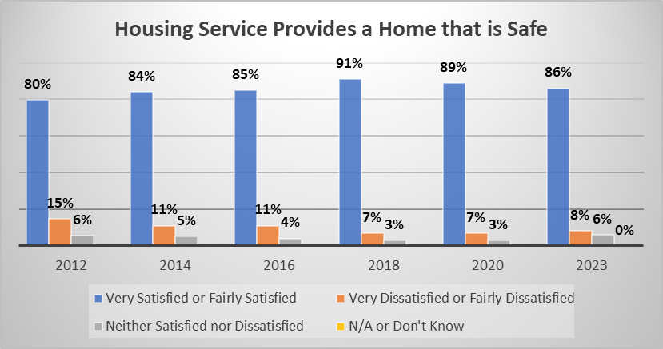 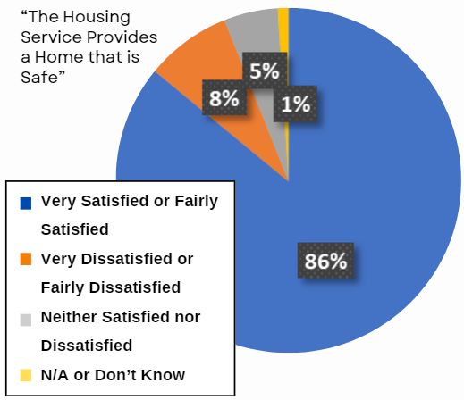

**Figure 15**: Pie chart showing the respondents’ satisfaction with the statement: “The Housing Service **Provides a Home that is Safe**”. The chart shows that 86% of respondents were very satisfied or fairly satisfied with the statement, 8% were very dissatisfied or fairly dissatisfied, 5% responded with neither satisfied nor dissatisfied, and 1% responded ‘not applicable or don’t know’.

**Since STAR Survey 2020:**

* A decrease by 3% of tenants who responded to the survey were satisfied that we provide safe homes.
* 1% more respondents were dissatisfied that we provide safe homes.
* 2% more respondents responded were neither satisfied nor dissatisfied that we provide safe homes.

**The responses to this question were marginally different between 2020 and 2023**. As has been the trend throughout the 2023 STAR Survey results so far, an increase in people who are neither satisfied nor dissatisfied has contributed to an overall drop in satisfaction.

It should be considered that a large proportion of our housing stock was built over 50 years ago, so these properties are beginning to require more maintenance. Over the last four years we have invested in maintenance programmes such as windows, doors, kitchen and bathroom replacements.

In the last two years the service has not had to report any Health and Safety incidents to the Housing Regulator.

**Figure 16**: Bar graph titled: “Responses to the statement: ‘The Housing Service provides a home that is well maintained.’”. As with Figure 12, this graph spans from 2012 to 2023 and shows the percentage of respondents who were very satisfied or fairly satisfied, very dissatisfied or fairly dissatisfied, or Neither Satisfied nor Dissatisfied toward the statement.

* **For “Very Satisfied” or “Fairly Satisfied”**: 2012 was at 83%, 2014 at 84%, 2016 at 87%, 2018 at 90%, 2020 at 88%, 2023 at 81%.
* **For “Very Dissatisfied” or “Fairly Dissatisfied”**: 2012 was at 10%, 2014 at 9%, 2016 at 8%, 2018 at 6%, 2020 at 7%, and 2023 at 9%.
* **For “Neither Satisfied nor Dissatisfied”:** 2012 was at 7%, 2014 was also at 7%, 2016 was at 5%, 2018 at 4%, 2020 at 5%, and 2023 at 8%.

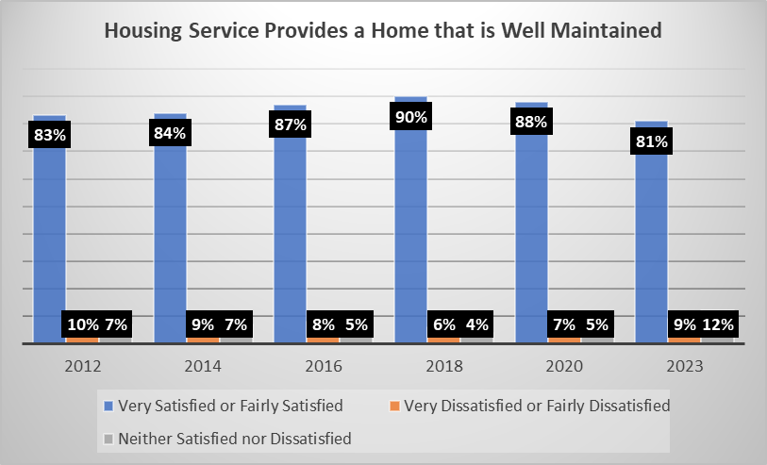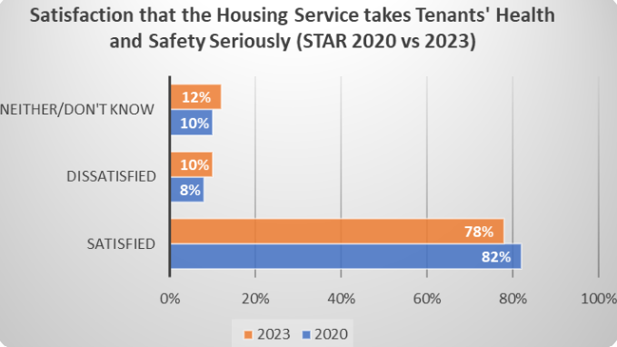

**Figure 17**: Bar graph titled: “Satisfaction that the Housing Service takes tenants’ Health and Safety seriously (STAR 2020 vs 2023)”. Satisfaction levels for this statement dropped from 82% in 2020 to 78% in 2023, meanwhile dissatisfaction levels rose from 8% to 10% in the same timeframe. The level of Neither Satisfied nor Dissatisfied responses between 2020 and 2023 also increased, from 10% to 12% respectively.

## Advice and Support

The 12% increase in satisfaction with support for vulnerable tenants coincides with our successful Erosh Accreditation campaign and drive of focus groups within Sheltered schemes. However, GovMetrics’ Customer Experience data showed that the main cause for dissatisfaction was a delay in call backs to tenants when asking for advice or requiring support. This is being addressed by the Resident Access team to ensure that call backs are made by the appropriate service area team/manager when required, and service standards are being developed which will be published to help manage expectations.

**Since STAR Survey 2020…**

* 9% fewer tenants were satisfied with **advice on claiming Housing Benefit and Welfare Benefits** in 2023.
* 1% fewer tenants were satisfied with **advice on managing finances and paying rent.**
* Satisfaction with **support available for vulnerable tenants** has **risen by 12%**.

### **Advice and Support Overview:**

* There has been a decrease in satisfaction with advice on claiming benefits and paying rent, of 9% and 1% respectively.
* The rate of dissatisfaction for both the above has **remained the same since 2020**: at 2% each, as shown in Figures 18 and 19 below.
* The **number of “Not Applicable” responses has increased**, driving the satisfaction rates down in the process. This aligns with what we have seen throughout the STAR 2023 results so far.
* The 12% increase in satisfaction with support for vulnerable tenants coincides with our successful Erosh Accreditation campaign and drive of focus groups within Sheltered schemes.

### **Advice on claiming benefits.**

**Figure 18**: Line graph titled: “Satisfaction with advice on claiming Housing Benefit and Welfare Benefits”. The four lines plotted on this graph represent the percentage of tenants who responded as being satisfied, dissatisfied, neither, or not applicable with the Housing Service’s advice on claiming benefits between 2012 and 2023.

[Graphs on next page.]

* **For “Satisfied”**: 2012 was at 55%, 2014 at 58%, 2016 at 52%, 2018 at 59%, 2020 at 58%, and 2023 at 49%.
* **For “Dissatisfied”**: 2012 was at 5%, 2014 was also at 5%, 2016 wat at 6%, 2018 down to 4%, 2020 down again to 2%, and 2023 remaining at 2%.
* **For “Neither”**: 2012 was at 14%, 2014 at 15%, 2016 at 10%, 2018 at 19%, 2020 at 18%, and 2023 down to 3%.
* **For “Not Applicable”**: 2012 was at 26%, 2014 at 22%, 2016 at 32%, 2018 at 19%, 2020 at 23%, and 2023 at 46%.

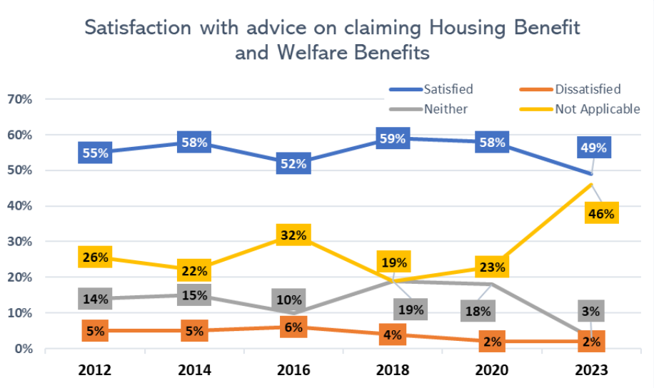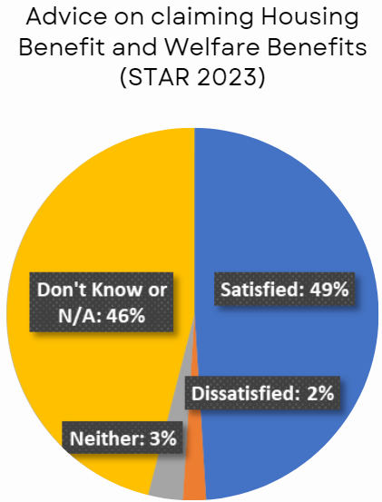

**Figure 19**: Pie chart titled: “Advice on claiming Housing Benefit and Welfare Benefits (STAR 2023)”. The chart shows that, in 2023, 49% of tenants who responded to the STAR Survey were satisfied with benefits advice, whilst 2% were dissatisfied, 3% chose ‘neither’, and 46% chose ‘don’t know or not applicable’.

Figures 18 and 19 above show changes in satisfaction levels with **advice on claiming benefits**. Positively, **dissatisfaction remains low at only 2%**, the same as in 2020. **The rate of “Not Applicable” responses has doubled** since the last survey, **now 46%**, indicating that far fewer tenants have submitted a benefits application since 2020.

### **Advice on managing finances and paying rent.**

**Figure 20**: Bar graph titled: “Satisfaction with advice on managing finances and paying rent”. The bars plotted on this graph represent the percentages of tenants who chose ‘satisfied’, ‘dissatisfied’, ‘neither’, and ‘not applicable’ to this question in the STAR Surveys in 2012 to 2023.

[Graphs on next page.]

* **For “Satisfied”**: 2012 was at 53%, 2014 at 59%, 2016 at 56%, 2018 at 63%, 2020 at 67%, and 2023 at 61%.
* **For “Dissatisfied”**: 2012 was at 6%, 2014 at 4%, 2016 also at 4%, 2018 also at 4%, 2020 at 2%, and 2023 also at 2%.
* **For “Neither”**: 2012 was at 15%, 2014 at 16%, 2016 at 13%, 2018 at 14%, 2020 at 10%, and 2023 at 9%.
* **For “Not Applicable”**: 2012 was at 26%, 2014 at 21%, 2016 at 27%, 2018 at 21%, 2020 at 22%, and 2023 at 27%.

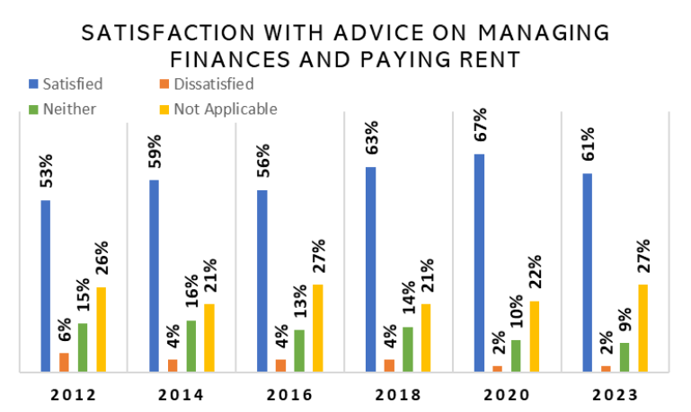

* As highlighted in Figure 20, there has been a **5% decrease in satisfaction with advice on managing finances and paying rent.**
* The percentage of tenants whom this was **not applicable** to when responding to the STAR survey also **increased by 5%**.
* Our Rents team are always available to offer advice.
* The data to the left indicates the effect of the Cost-of-Living Crisis on tenants.
* Tenants of Sheltered schemes were nearly 10% more satisfied with advice on managing finances and paying rent than tenants in General Needs homes.
* As of January 2024, **201 tenants (8% of all tenants)** had received support from our Tenancy Sustainment Officers in 23/24. This includes the submittal of **50 applications** for DHPs, or Discretionary Housing Payments.
* At the time of reporting, the Tenancy Sustainment Officers, or TSOs, had helped **contribute £158k in benefits and payments to rent accounts** in 23/24 through supporting tenants manage their finances, **and another £158k in benefits payments paid directly to tenants.**

### **Support for vulnerable tenants.**

**Figure 21**: Bar graph titled: “Satisfaction with support for vulnerable tenants (STAR 2012 to 2023)”. The bars plotted on this graph represent the percentages of tenants who chose ‘satisfied’, ‘dissatisfied’, ‘neither’, and ‘not applicable’ to this question in the STAR Surveys in 2012 to 2023.

* **For “Satisfied”**: 2012 was at 26%, 2014 at 29%, 2016 at 23%, 2018 at 29%, 2020 at 25%, and 2023 at 37%.
* **For “Dissatisfied”**: 2012 was at 9%, 2024 also at 9%, 2016 at 8%, 2018 at 5%, 2020 at 8%, and 2023 at 11%.
* **For “Neither”**: 2012 was at 28%, 2014 at 28%, 2016 at 21%, 2018 at 27%, 2020 at 16%, and 2023 at 15%.
* **For “Not Applicable”**: 2012 was at 37%, 2014 at 34%, 2016 at 48%, 2018 at 39%, 2020 at 52%, and 2023 at 38%.

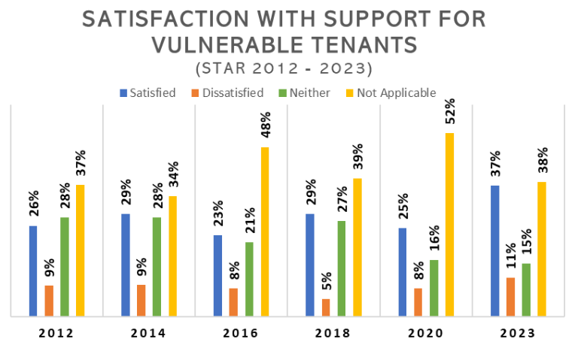 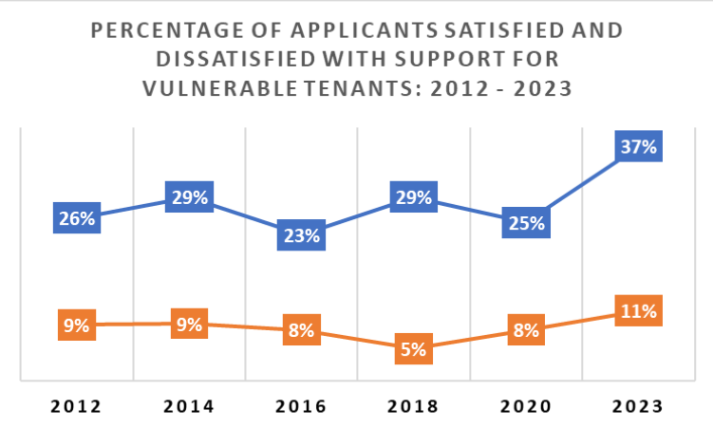

**Figure 22**: Line graph titled: “Percentage of applicants satisfied and dissatisfied with support for vulnerable tenants: 2012-2023”. This graph highlights the same data from Figure 20, focusing specifically on satisfaction and dissatisfaction levels.

* **For “Satisfied”**: 2012 was at 26%, 2014 at 29%, 2016 at 23%, 2018 at 29%, 2020 at 25%, and 2023 at 37%.
* **For “Dissatisfied”**: 2012 was at 9%, 2024 also at 9%, 2016 at 8%, 2018 at 5%, 2020 at 8%, and 2023 at 11%.
* Satisfaction rose by 12% with the support we offer for vulnerable tenants, however there was a 3% increase in those who were dissatisfied.
* More people felt this question was **applicable to them in 2023** than in 2020. This suggests that we now have more tenants who consider themselves to be vulnerable and/or have accessed support from us.
* Being able to support our more vulnerable tenants is **a vital part of our service** and will always be treated as such. The service has begun a program of tenant audits in order to better understand tenant/household needs so that we can offer increased support to those who need it.
* We are also introducing a survey for new tenants so we are aware of any additional needs they may have, so that we can provide additional support to them if required.

## Contacts and communication

It is useful to know how the majority of you prefer to contact us so that we can tailor our services accordingly.

**Figure 23**: Pie chart titled: “Preferred contact methods of tenants in 2023 (according to the STAR Survey)”. This pie chart is segmented into the six methods of communication given as options on the STAR Survey 2023, excluding other options which received no votes. The results are as follows:

* **Email**: 19.01%
* **Telephone**: 67.96%
* **Text/SMS**: 3.52%
* **In writing**: 7.39%
* **Visit to the office**: 0.35%
* **Visit to your home by staff**: 1.76%

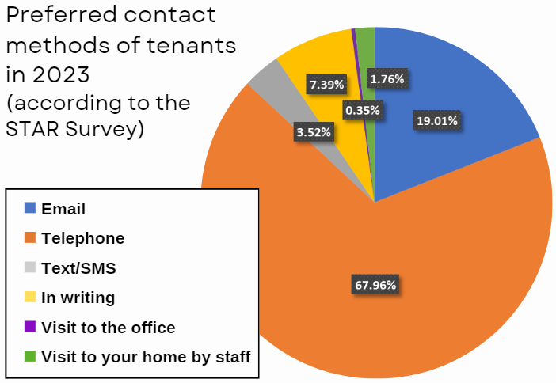

As shown, the **majority of tenants still prefer the telephone** as their primary communication method. This aligns with what many other housing providers have found, though it is worth noting that **our service does not currently have many digital offerings** for tenants to manage their tenancy. We will always offer phone calls as a way to contact us, but we are looking to explore more digital options in addition for those who would prefer alternative routes, including the possibility of developing a ‘tenant portal’ to enable tenants to have more control over their tenancy.

## Neighbourhood

Developing safe and appealing neighbourhoods is just as important to us as the quality of our homes. These questions help us to gauge which areas of neighbourhood management we should focus on most.

**Figure 24**: Pie chart titled: “Satisfaction that the Housing Service makes a positive contribution to neighbourhoods”. The chart shows that, in 2023, 48% of tenants who responded to the survey were very satisfied or fairly satisfied with the statement, 14% were very dissatisfied or fairly dissatisfied, and the remaining 38% were Neither Satisfied nor Dissatisfied.

* Since 2020, there has been a **decrease in satisfaction** that we, as a landlord, make a positive contribution to neighbourhoods. from 2020. Satisfaction levels have **dropped from 76% to 48%** since the last survey.
* This continues the trend of declining satisfaction we have seen in this area since the COVID-19 pandemic, when lockdown measures were in place which meant that your neighbourhood and surrounding area became more important.
* We are looking to hold parish-specific focus groups with our tenants to better understand what improvements we could make to their neighbourhood.

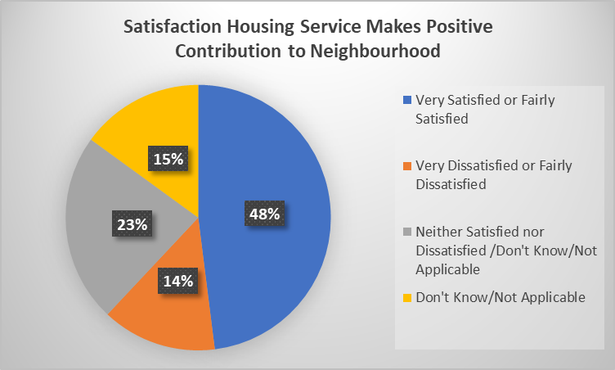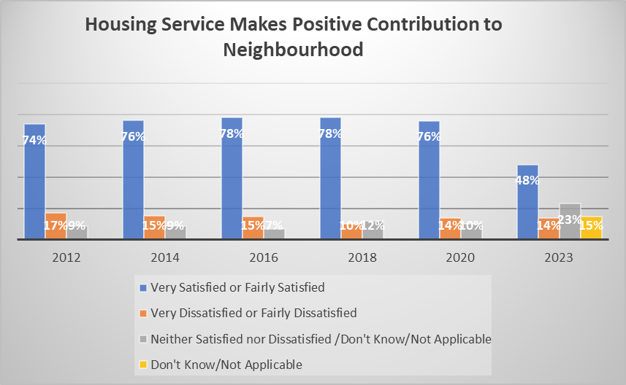

**Figure 25**: Bar graph titled: “Responses to the statement: ‘The Housing Service Makes a Positive Contribution to the Neighbourhood’”. This graph shows the percentages of tenants who were very satisfied or fairly satisfied, very dissatisfied or fairly dissatisfied, or who chose ‘neither or don’t know’ in every STAR Survey from 2012 to 2023.

* **For “Very Satisfied” or “Fairly Satisfied”**: 2012 was at 74%, 2014 at 76%, 2016 at 78%, 2018 also at 78%, 2020 down to 76%, and 2023 down to 48%.
* **For “Very Dissatisfied” or “Fairly Dissatisfied”**: 2012 was at 17%, 2014 at 15%, 2016 also at 15%, 2018 at 10%, 2020 at 14%, and 2023 also at 14%.
* **For “Neither or Don’t Know”**: 2012 was at 9%, 2014 also at 9%, 2016 at 7%, 2018 at 12%, 2020 at 10%, and 2023 up to 38%.
* **11% of respondents believed their neighbourhoods have improved in the last 2 years.**
* **14% of respondents believed their neighbourhoods have declined in the last 2 years.**
* **75% of respondents believed their neighbourhoods have stayed the same in the last 2 years.**

An overwhelming **75% of tenants said that their neighbourhood has stayed the same** in the last year. In light of this, we are reintroducing neighbourhood walkabouts to identify potential improvements that the service can implement to improve the appearance of our neighbourhoods.

## Lettings

8.5% of those in General Needs and 10.9% of those in Sheltered who responded to the 2023 STAR Survey had moved into a new Wokingham Borough Council property in the last 2 years.

**Figure 26**: Bar graph showing tenants’ overall satisfaction with the lettings process, comparing results from the STAR Survey in 2020 to 2023.

[Graphs on next page.]

* **In 2020**: 90% of tenants who responded were satisfied or very satisfied with the lettings process, 6% were dissatisfied or very dissatisfied, and 4% chose ‘neither or don’t know’.
* **In 2023**: 84% of respondents were satisfied or very satisfied, 4% were dissatisfied or very dissatisfied, and 12% chose ‘neither or don’t know’.

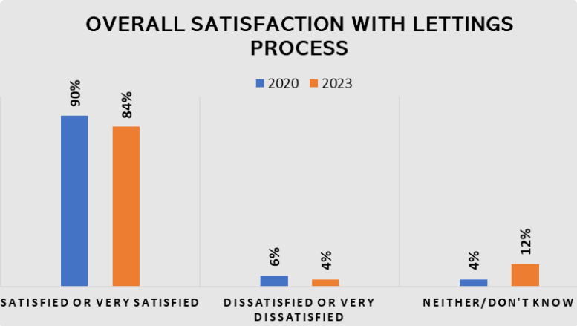

* Satisfaction with the Lettings service (i.e., re-letting void, or empty, properties) **remains positive**.
* Although there has been a decrease in satisfaction, the **overall satisfaction score is at 84%**.
* Once again, dissatisfaction with the lettings service has seen a decrease, with **a much higher percentage of tenants selecting the “neither/don’t know” option**.

**Figure 27**: Bar graph showing tenants’ satisfaction with information provided during the lettings process, comparing results between 2020 and 2023. The results are as follows:

* **In 2020**: 87% of tenants who responded were satisfied or very satisfied, 8% were dissatisfied or very dissatisfied, and 5% chose ‘neither or don’t know’.
* **In 2023**: 86% of respondents were satisfied or very satisfied, 8% were dissatisfied or very dissatisfied, and 6% chose ‘neither or don’t know’.

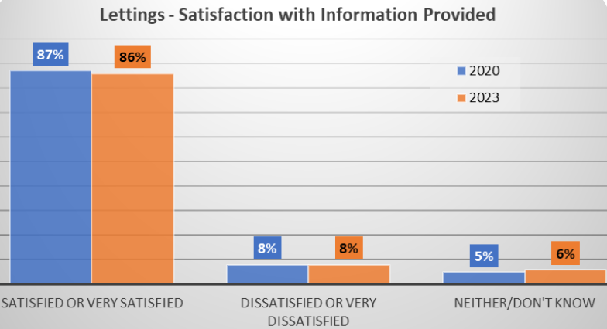 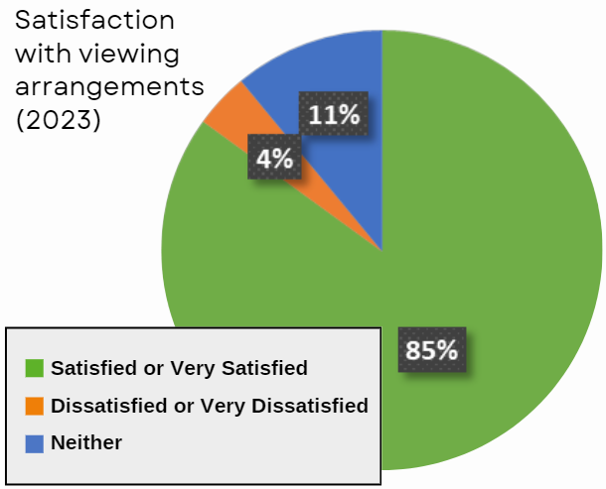

**Figure 28**: Pie chart showing levels of satisfaction, dissatisfaction, and tenants who chose ‘neither’ with regards to the viewing arrangements made during the lettings process. The chart shows that 85% of tenants who responded were satisfied or very satisfied with viewing arrangements, 4% were dissatisfied or very dissatisfied, and the remaining 11% were Neither Satisfied nor Dissatisfied.

**Since the STAR Survey in 2020:**

* Overall satisfaction for the lettings process has fallen by 6% since 2020.
* Overall dissatisfaction for the lettings process has also fallen, by 2%.
* 8% more people who replied to the survey were Neither Satisfied nor Dissatisfied or did not know.

Despite slight decreases in satisfaction across the board, the satisfaction levels for all questions regarding the Lettings service are **higher than 80%**. The Lettings team have consistently kept tenants informed throughout the process, as shown in the graph in the top left, with dissatisfaction levels remaining consistent at 8% between 2020 and 2023. 83% of tenants said they were satisfied with the helpfulness of staff during the lettings process.

**Figure 29**: Bar graph showing the levels of satisfaction with the helpfulness of staff during the lettings process, comparing STAR Survey results from 2020 and 2023. The results read as follows:

* **In 2020**: 88% of tenants who responded were satisfied or very satisfied, 8% were dissatisfied or very dissatisfied, and 4% chose ‘neither or don’t know’.
* **In 2023**: 83% of respondents were satisfied or very satisfied, 8% were dissatisfied or very dissatisfied, and 9% chose ‘neither or don’t know’.

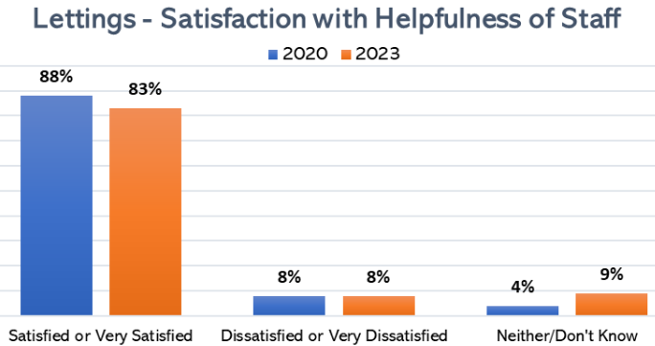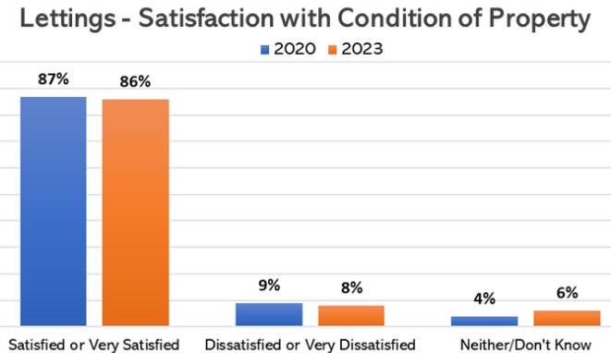

**Figure 30**: Bar graph showing the levels of satisfaction with the condition of a newly let property, comparing STAR Survey results from 2020 and 2023. The results read as follows:

* **In 2020**: 87% of tenants who responded were satisfied or very satisfied, 9% were dissatisfied or very dissatisfied, and 4% chose ‘neither or don’t know’.
* **In 2023**: 86% of respondents were satisfied or very satisfied, 8% were dissatisfied or very dissatisfied, and 6% chose ‘neither or don’t know’.

**Figure 31**: Bar graph showing a breakdown between General Needs and Sheltered tenants’ overall satisfaction with the lettings process in 2023. The results read as follows:

* **For General Needs**: 79.2% of tenants who responded were satisfied or very satisfied, 4.2% were dissatisfied or very dissatisfied, and 16.7% chose ‘neither or don’t know’.
* **For Sheltered**: 85.7% of respondents were satisfied or very satisfied, 0% were dissatisfied or very dissatisfied, and 14.3% chose ‘neither or don’t know’.

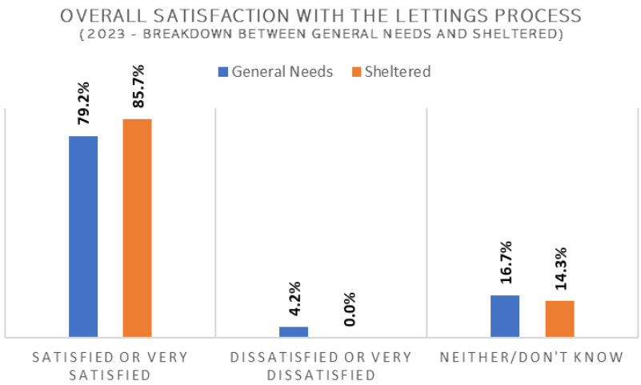

We will be introducing a new survey which will be conducted 4 weeks after a tenant has moved in to ascertain any additional requirements, they may have to ensure we meet their needs.

We are also currently updating our Tenant Handbook to improve the clarity of information provided to new and current tenants. This will be in the form of a series of leaflets to make them easy to update when required.

## Responsive Repairs

72% of people who responded to the survey told us that a repair has been carried out in their home in the last year. According to industry experts HouseMark, certain environmental and economic factors are putting landlords’ repairs services under pressure, leading to more complaints. This includes extreme weather such as storms, floods, and ice; labour and material shortages; delays caused by rises in inflation; and Brexit, which has led to delivery delays and increased costs of resources. These factors have affected the contractor’s performance, particularly in completing jobs on time and right first time.

**Figure 32**: Bar graph titled: “Overall satisfaction with the repairs service”. This graph compares data from the STAR Surveys undertaken in 2012 through to 2023, with bars representing the percentage of tenants who responded who were very satisfied or fairly satisfied, very dissatisfied or fairly dissatisfied, and who chose ‘neither satisfied nor dissatisfied’ in each period.

* **For “Very Satisfied” or “Fairly Satisfied”**: 2012 was at 82%, 2014 at 84%, 2016 at 83%, 2018 at 93%, 2020 at 91%, and 2023 at 82%.
* **For “Very Dissatisfied” or “Fairly Dissatisfied”**: 2012 was at 12%, 2014 at 9%, 2016 at 8%, 2018 at 5%, 2020 at 6%, and 2023 up to 13%.
* **For “Neither Satisfied nor Dissatisfied”**: 2012 was at 6%, 2014 at 7%, 2016 at 9%, 2018 at 2%, 2020 at 3%, and 2023 at 5%.

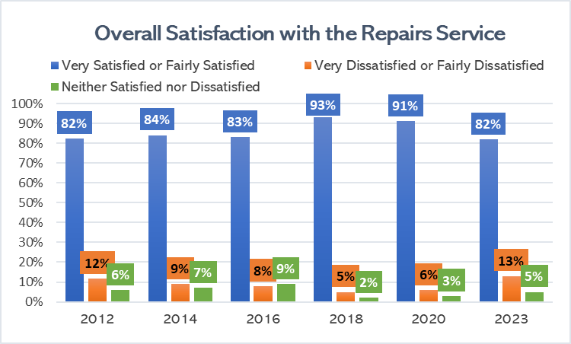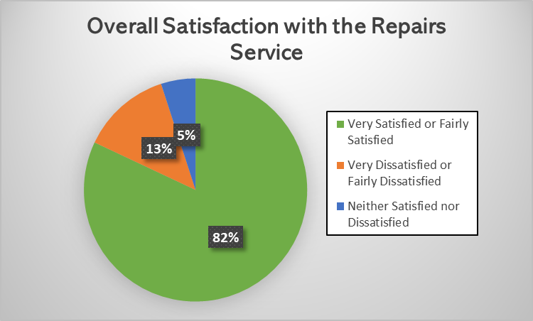

**Figure 33**: Pie chart showing the overall tenant satisfaction levels with the repairs service in 2023, according to the latest STAR Survey. This shows that 82% of the tenants who responded to the survey were very satisfied or fairly satisfied, 13% were very dissatisfied or fairly dissatisfied, and the remaining 5% were Neither Satisfied nor Dissatisfied.

**Since STAR Survey 2020:**

* 3% fewer tenants are satisfied that we provide safe homes.
* 1% more tenants are dissatisfied that we provide safe homes.
* 2% more tenants are neither satisfied nor dissatisfied that we provide safe homes.

In the previous two STAR surveys (2018 & 2020) the service saw levels of satisfaction with the repairs service increase to over 90%.

There was a drop in satisfaction levels in 2023, coinciding with trends seen in the contractor’s performance.

Factors such as increasing difficulty to source parts has had a knock-on effect on repairs, highlighted in the graph below, were satisfaction with the speed of completing work fell by 9% from 2020 to 2023.

The Repairs Service has also suffered from the effects of Brexit, which has caused a surge in material costs as well as shortages and delays with deliveries.

**Figure 35**: Line graph titled: “Percentage of tenants satisfied or dissatisfied with the amount of time taken before repair works (STAR Survey: 2012-2023)”. This graph highlights the levels of satisfaction and dissatisfaction of tenants who responded to our STAR Surveys from 2012 to 2023, with regard to the amount of time taken before repair works.

* **For “Satisfied”**: 2012 was at 78%, 2014 was also at 78%, 2016 also remained at 78%, 2018 increased to 88%, 2020 remained at 88%, and 2023 dropped to 82%.
* **For “Dissatisfied”**: 2012 was at 15%, 2014 at 13%, 2016 at 12%, 2018 at 5%, 2020 at 7%, and 2023 at 10%.
* **Note**: This graph does not include the percentage of Neither Satisfied nor Dissatisfied responses.

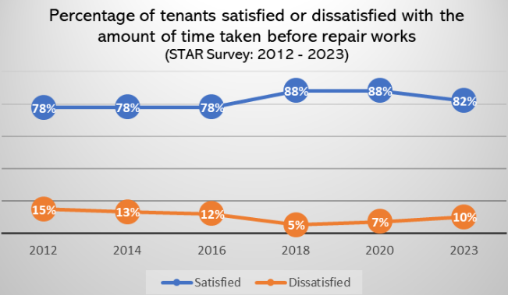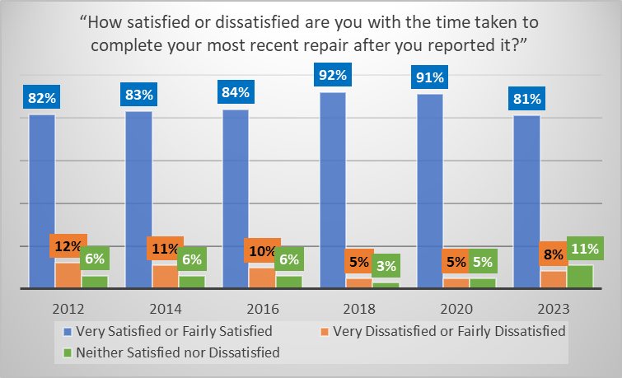

**Figure 36**: Bar graph titled: “How satisfied or dissatisfied are you with the time taken to complete your most recent repair after you reported it?”. This graph also spans from 2012 to 2023, showing the percentages of tenants very satisfied or fairly satisfied, very dissatisfied or fairly dissatisfied, and Neither Satisfied nor Dissatisfied at the time of each survey.

* **For “Very Satisfied” or “Fairly Satisfied”**: 2012 was at 82%, 2014 at 83%, 2014 at 84%, 2018 at 92%, 2020 at 91%, and 2023 at 81%.
* **For “Very Dissatisfied” or “Fairly Dissatisfied”**: 2012 was at 12%, 2014 at 11%, 2016 at 10%, 2018 at 5%, 2020 also at 5%, and 2023 at 8%.
* **For “Neither Satisfied nor Dissatisfied”**: 2012 was at 6%, 2014 also at 6%, 2016 also at 6%, 2018 at 3%, 2020 at 5%, and 2023 at 11%.

**Figure 37**: Pie chart titled: “Satisfaction with the **attitude of workers**”. The chart shows at 89% of tenants who responded to the STAR Survey in 2023 were satisfied with the attitude of repair workers, whilst 5% were dissatisfied and 6% were Neither Satisfied nor Dissatisfied.

* The **attitude of workers** carrying out repairs has been identified as positive, seeing **just a 2% decrease in satisfaction from 2020**, whilst **dissatisfaction in 2023** **remained at 5%** for the second survey running.
* **6% of survey participants gave a Neither Satisfied nor Dissatisfied answer** to this question, more than the rate of dissatisfied customers.

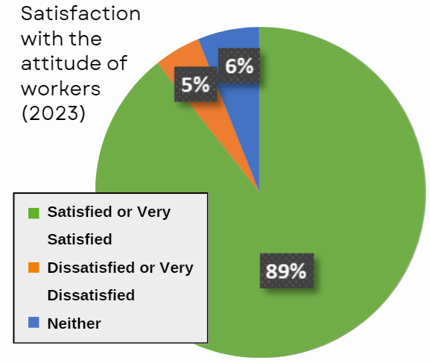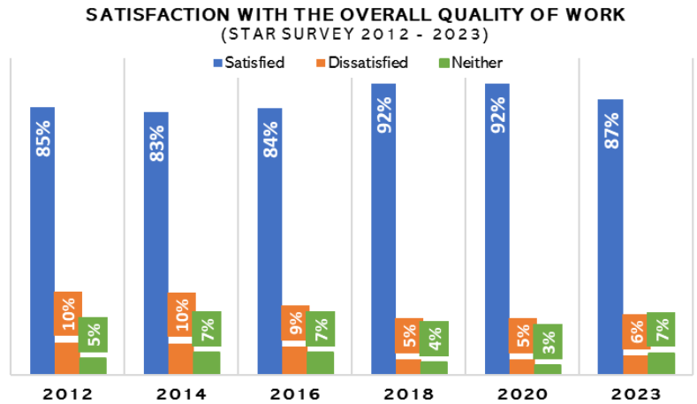

**Figure 38**: Bar graph titled: “Satisfaction with the **overall quality of work**”. The bars plotted on this graph represent the percentages of tenants who responded to the question who were satisfied, dissatisfied, or chose ‘neither’, in STAR Surveys from 2012 to 2023.

* **For “Satisfied”**: 2012 was at 85%, 2014 at 83%, 2016 at 84%, 2018 at 92%, 2020 also at 92%, and 2023 at 87%.
* **For “Dissatisfied”**: 2012 was at 10%, 2014 also at 10%, 2016 at 9%, 2018 at 5%, 2020 also at 5%, and 2023 at 6%.
* **For ‘Neither’**: 2012 was at 5%, 2014 at 7%, 2016 also at 7%, 2018 at 4%, 2020 at 3%, and 2023 at 7%.

After seeing a **peak of 92% in the two previous surveys**, overall quality of work saw a **5% decrease in 2023**, indicative of the results seen for responsive repairs as a whole. Dissatisfaction levels for the same question have **risen by 1%**, however this remains lower than the level of ‘Neither Satisfied nor Dissatisfied’ responses.

**Figure 39**: Bar graph titled: “Satisfaction that the repair was done right first time (STAR Survey 2012-2023)”. The bars plotted on this graph represent the percentages of tenants who responded to the question who were satisfied, dissatisfied, or chose ‘neither’, in STAR Surveys from 2012 to 2023.

* **For “Satisfied”**: 2012 was at 74%, 2014 at 78%, 2016 also at 78%, 2018 at 88%, 2020 at 90%, and 2023 down to 75%.
* **For “Dissatisfied”**: 2012 was at 18%, 2014 at 14%, 2016 at 13%, 2018 at 8%, 2020 at 5%, and 2023 up to 14%.
* **For ‘Neither’**: 2012 was at 8%, 2014 also at 8%, 2016 at 9%, 2018 at 5%, 2020 at 6%, and 2023 up to 11%.

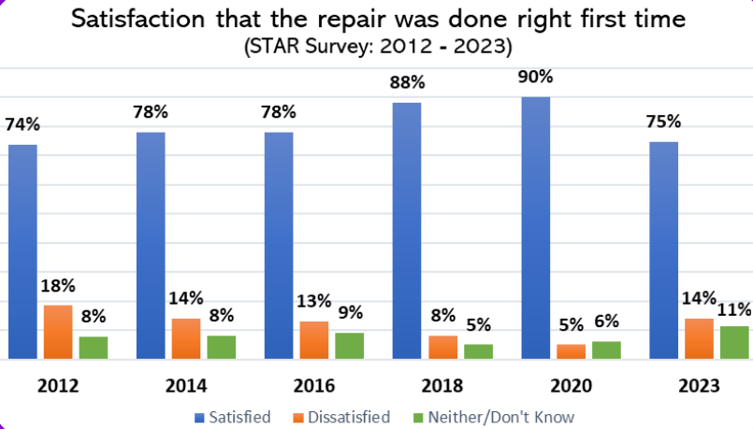

The percentage of tenants satisfied that their repairs were done **right first time** has dropped quite significantly between 2020 and 2023, **from 90% to 75%**. As stated above, repair services nationally have been impacted by the time taken to source parts and the lack of operatives in the sector, which has impacted performance levels.

* Whilst we would consider anything above 80% to be ‘good’, the quality of repair works directly reflects that of your homes as a whole, so we want repairs to be of the highest quality possible.
* The issues around responsive repairs have been continually addressed by our Repairs Service with our contractor and the last five months have seen an improvement in performance, particularly in jobs completed on time and right first time (94% on time and 93% right first time).
* We are already sending tenants satisfaction surveys after a repair has been completed, and again we are seeing increases in satisfaction. In the last five months, overall satisfaction with the repairs service has been at 92%.

## Anti-Social Behaviour (ASB)

Managing and preventing ASB is a key element of our neighbourhood management, allowing our residents to live peacefully in safe and pleasant homes. As part of the Housing Improvement Programme, the way in which we respond to and prevent ASB will be changing. Embedding early intervention into our services, Housing Officers and our ASB specialist will be working in partnership to ensure that our residents know when they can expect a response from us and receive an action plan when they report ASB. The action plan will set out next steps and provide advice, information and where appropriate signposting to other agencies. Putting our tenants at the heart of how cases of ASB are managed is essential to ensure that they feel heard and fully included in the process. As we will be able to manage their expectations from the outset, it is intended that this new approach will result in greater understanding of the process from start to finish and reduce the number of Neither Satisfied nor Dissatisfied and ‘don’t know’ responses, leading to an overall improvement in customer satisfaction.

**In the 2023 STAR Survey:**

* 28% of tenants who responded were very satisfied or fairly satisfied with the Housing Service’s approach to handling anti-social behaviour.
* 11% of tenants were very dissatisfied or fairly dissatisfied with the Housing Service’s approach to handling anti-social behaviour.
* 28% were Neither Satisfied nor Dissatisfied towards the Housing Service’s approach to handling anti-social behaviour.
* 33% answered “Not Applicable or Don’t Know” to the question.

### **Overview of ASB:**

* **Less than 30%** of tenants responded that they were satisfied with the service’s handling of ASB.
* **61%** of STAR Survey 2023 participants were **either Neither Satisfied nor Dissatisfied or did not know how to respond** to this question.
* With **32% of participants dissatisfied with the ease of reporting ASB**, it is clear that more work needs to be done to support tenants to do this. Extra administrative support has been brought in to make our ASB case management more efficient.

**Figure 40**: Bar graph titled: “Satisfaction with the ease of contacting the Housing Service to report an ASB issue (STAR Survey 2023; General Needs and Sheltered)”. This graph compares the level of satisfaction with the aforementioned question between tenants in General Needs and Sheltered homes. The graph shows that, on average, Sheltered tenants are more satisfied with the ease of reporting ASB, at 64.24% satisfied, compared to General Needs tenants at 48.39% satisfied.

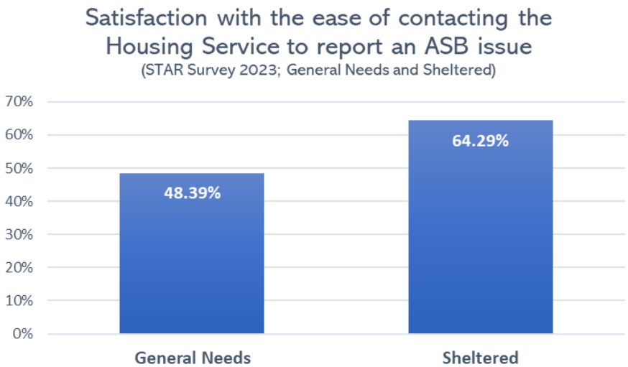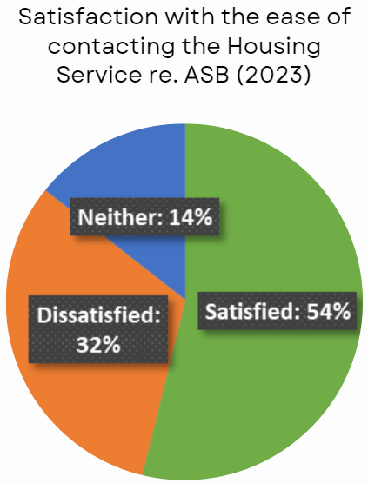

**Figure 41**: Pie chart titled: “Satisfaction with the ease of contacting the Housing Service regarding ASB (2023)”. The chart shows that, of all the tenants who responded to the 2023 STAR Survey: 54% were satisfied, 32% were dissatisfied, and 14% chose ‘neither’.

## Complaints

20% of General Needs residents and 16% of Sheltered residents who responded to the STAR Survey told us that they have made a formal complaint in the last 12 months. The following results reflect their views of the service area.

*[Note: This section of the report regards Housing-related complaints only.]*

**Figure 42**: Pie chart showing “Satisfaction with the Housing Service’s approach to complaints handling”, according to the STAR Survey 2023. The chart shows that only 48% of tenants who responded to the survey are very satisfied or fairly satisfied with the Housing Service’s overall approach to complaints handling, whilst 34% are very dissatisfied or fairly dissatisfied and 18% are Neither Satisfied nor Dissatisfied.

* **Less than half** of those who responded saying they had made a complaint in the last 12 months were very satisfied or fairly satisfied with the Service’s approach.
* One of the key issues is the **time taken to resolve complaints**.
* There is more awareness of complaints among tenants nationally due to campaigns from government and the Housing Ombudsman.

**Figure 43**: Bar graph titled: “Satisfaction with the ease of making a complaint to the Housing Service”. The data in this graph is from each STAR Survey between 2012 and 2023 and shows the percentages of tenants who responded who were satisfied, dissatisfied, and Neither Satisfied nor Dissatisfied with the ease of making a complaint. The results are as follows:

* **For “Satisfied”:** 2012 was at 61%, 2014 at 66%, 2016 at 72%, 2018 at 73%, 2020 at 76%, and 2023 down to 56%.
* **For “Dissatisfied”:** 2012 was at 25%, 2014 at 17%, 2016 at 15%, 2018 also at 15%, 2020 at 11%, and 2023 up to 26%.
* **For “Neither or Don’t Know”:** 2012 was at 14%, 2014 at 17%, 2016 at 13%, 2018 also at 13%, 2020 at 10%, and 2023 at 18%.

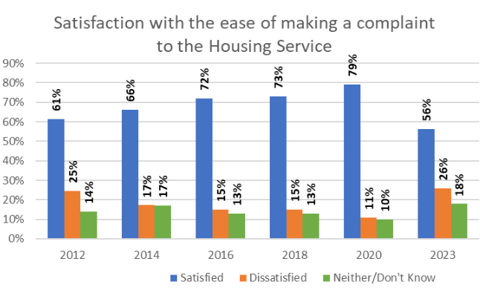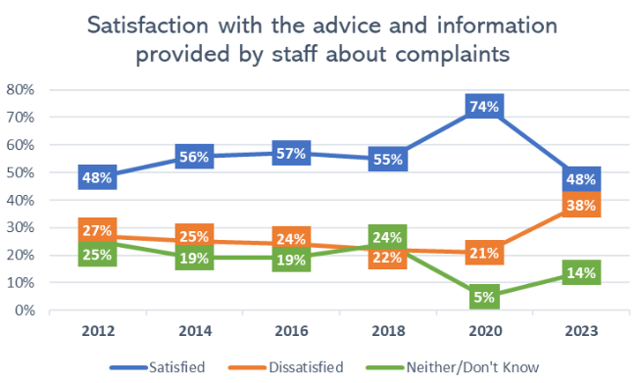

**Figure 44**: Line graph titled: “Satisfaction with the advice and information provided by staff about complaints”. The lines on this graph represent the percentages of tenants who responded to the survey who were satisfied, dissatisfied, and Neither Satisfied nor Dissatisfied with the aforementioned question, in STAR Surveys from 2012 to 2023.

* **For “Satisfied”:** 2012 was at 48%, 2014 at 56%, 2016 at 57%, 2018 at 55%, 2020 at 74%, and 2023 down to 48%.
* **For “Dissatisfied”:** 2012 was at 27%, 2014 at 25%, 2016 at 24%, 2018 at 22%, 2020 at 21%, and 2023 up to 38%.
* **For “Neither or Don’t Know”:** 2012 was at 25%, 2014 at 19%, 2016 also at 19%, 2018 at 24%, 2020 down to 5%, and 2023 at 14%.

Across the board of questions related to complaints, the **levels of dissatisfaction and Neither Satisfied nor Dissatisfied responses have increased**. As shown in Figures 43 and 44, there has been a steep decline in satisfaction levels with the ease of making a complaint, despite the number of communications increasing to include social media.

**Figure 45**: Line graph titled: “Satisfaction with the speed with which a complaint was dealt”. The lines on this graph show the satisfaction scores for complaint handling speed from STAR Surveys in 2012 to 2023.

* **For “Satisfied”:** 2012 was at 39%, 2014 at 37%, 2016 at 38%, 2018 at 51%, 2020 at 62%, and 2023 down to 23%.
* **For “Dissatisfied”:** 2012 was at 46%, 2014 at 43%, 2016 at 44%, 2018 at 36%, 2020 at 23%, and 2023 up to 61%.
* **For “Neither or Don’t Know”:** 2012 was at 15%, 2014 at 20%, 2016 at 18%, 2018 at 14%, 2020 at 15%, and 2023 at 16%.

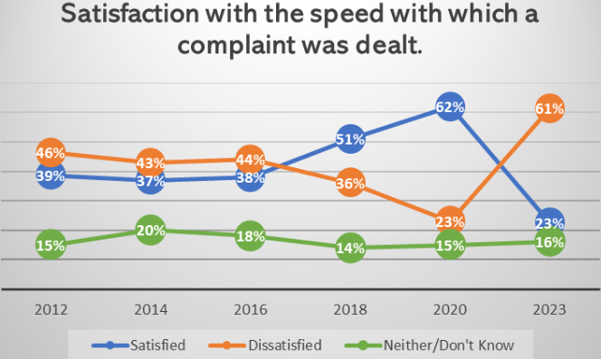

Satisfaction with the time taken for complaints to be dealt with has seen a larger fall than any other measure in the STAR survey - dropping by nearly 40%.

The decline in satisfaction for this measure aligns with our annual performance data. We have seen more delay notices issued for complaints in the 2023-24 financial year than any year prior, a statistic we aim to turn around completely in 2024.

The Service has recently introduced a new process for decreasing response times for complaint responses. This has already had an impact, with the last few months seeing a decrease in the number of delay notices issued.

Our Customer Care Team also recently ran a series of complaints workshops for Housing staff to improve our complaints management process across the Housing Service.

## Communal Buildings

22% of General Needs residents and 91% of Sheltered residents who responded to the STAR Survey live in a building with communal areas, either internal or external, highlighting the importance of keeping these safe.

**Figure 46**: Pie chart titled: “Satisfaction that communal areas are clean and well maintained”. This chart shows that, of the tenants who responded to this question in the STAR Survey 2023, 69% were very satisfied or fairly satisfied, 19% very dissatisfied or fairly dissatisfied, and 12% Neither Satisfied nor Dissatisfied regarding the maintenance of communal areas.

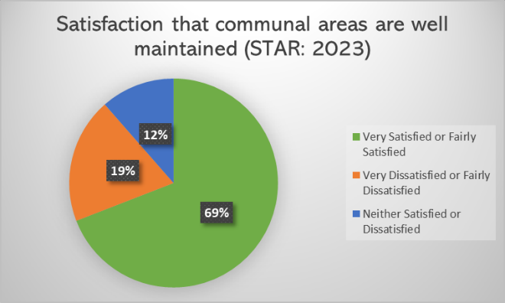

**Figure 47**: Pie chart titled: “Overall satisfaction with communal services (STAR: 2023)”. This chart shows that, with regard to the overall communal services, 59% of tenants who responded to the survey in 2023 were satisfied, whilst 33% were dissatisfied and 8% were Neither Satisfied nor Dissatisfied.

* Satisfaction levels that communal areas are well maintained, and overall satisfaction with communal services, have highlighted that changes are needed to the way we manage communal areas and buildings.
* In light of this data, the service has increased communal inspections to every six weeks, from every six months, by the Housing Management team.
* This will enable the service to ensure any maintenance issues are picked up on a regular basis and resolved.
* The required compliance checks are carried out in line with legislation and, over the past year, 100% of compliance checks have been completed in communal blocks.
* The service has also consulted with a specialist contractor on what measures needed to be put in place to ensure well maintained and health and safety compliant communal blocks, and we have begun to implement these recommendations.

## Sheltered Housing

The following results specifically regard our Sheltered Housing schemes. For the purpose of this report, **“ILO” refers to the Independent Living Officers** based in the schemes.

**Figure 48**: Pie chart titled: “Satisfaction with overall service from ILOs (2023)”. Of the Sheltered tenants who responded to this question in the STAR Survey, 73% were satisfied with the service provided by their ILOs, whilst 5% were dissatisfied and the remaining 22% were Neither Satisfied nor Dissatisfied.

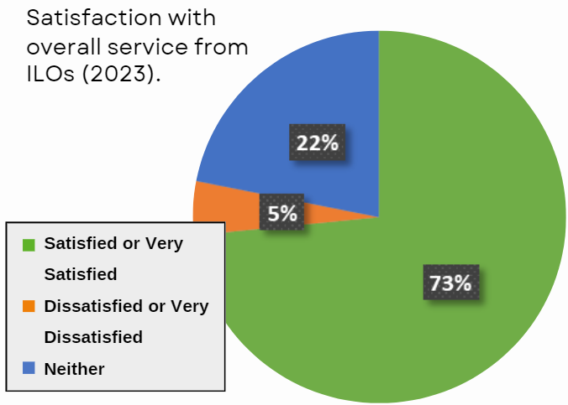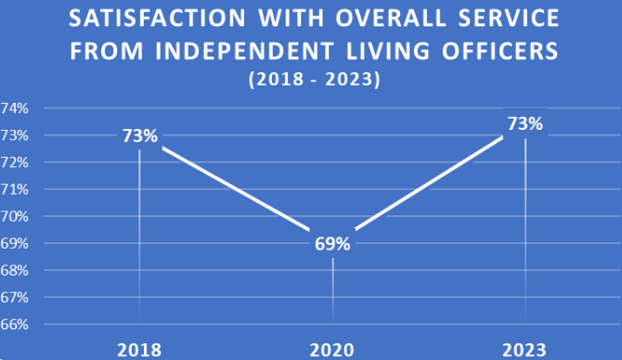

**Figure 49**: Line graph showing the trend in satisfaction with the overall service provided by Independent Living Officers (or ILOs), according to STAR Surveys from 2018 to 2023. [Note: this question was first included in the 2018 STAR Survey.] The graph shows that satisfaction levels for this question were at 73% in 2018, dropping to 69% in 2020, then rising back to 73% in 2023.

Overall satisfaction with the service from our Independent Living Officers has **risen back to the level seen in 2018**, before the COVID-19 pandemic limited what could be provided due to lock-down regulations. Over the last two years, the Sheltered service has been working on and achieved accreditation status from an independent accreditor. The accreditation status has coincided with improved satisfaction levels within Sheltered schemes. For more information on the accreditor, see the following page.

**Figure 50**: Bar graph showing trends in Sheltered tenants’ satisfaction with the frequency of contact with their ILO, from 2018 to 2023. The bars on this graph represent the levels of satisfaction, dissatisfaction, and Neither Satisfied nor Dissatisfied responses in each STAR Survey in which this question was asked.

* **For “Satisfied”**: 2018 was at 69%, 2020 dropped to 55%, and 2023 rose to 72%.
* **For “Dissatisfied”**: 2018 scored 12%, 2020 rose to 24%, and 2023 dropped to 5%.
* **For “Neither or Don’t Know”**: 2018 was at 19%, 2020 at 21%, and 2023 at 23%.

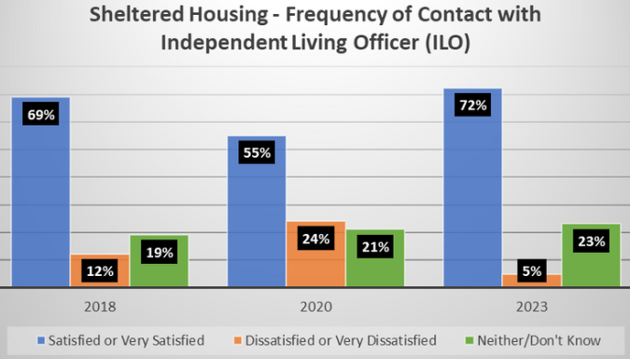

The level of tenants **satisfied with the frequency of contact they have with an Independent Living Officer (ILO) is now 72%**, higher than it has been since before 2018, meaning this area of the service has not only recovered from the pandemic but now **exceeds** the performance seen before it.

**Figure 51**: Bar graph showing Sheltered tenants’ satisfaction with their emergency call system, according to STAR Surveys from 2018 to 2023. The bars on this graph represent the levels of satisfaction, dissatisfaction, and Neither Satisfied nor Dissatisfied responses to this question.

* **For “Satisfied”**: 2018 was at 89%, 2020 at 87%, and 2023 at 88%.
* **For “Dissatisfied”**: 2018 was at 2%, 2020 at 5%, and 2023 at 3%.
* **For “Neither or Don’t Know”**: 2018 was at 9%, 2020 at 8%, and 2023 at 9%.

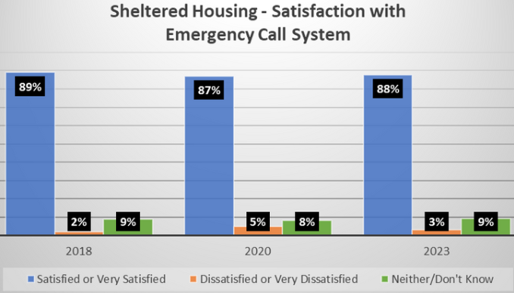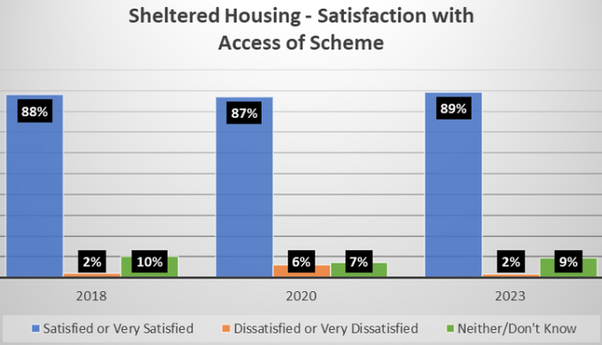

**Figure 52**: Bar graph showing Sheltered tenants’ satisfaction with the accessibility of their Sheltered Scheme, according to STAR Surveys from 2018 to 2023. The bars on this graph represent the levels of satisfaction, dissatisfaction, and Neither Satisfied nor Dissatisfied responses to this question.

* **For “Satisfied”**: 2018 was at 88%, 2020 at 87%, and 2023 at 89%.
* **For “Dissatisfied”**: 2018 was at 2%, 2020 at 6%, and 2023 at 2%.
* **For “Neither or Don’t Know”**: 2018 was at 10%, 2020 at 7%, and 2023 at 9%.
* ILOs are not available on the schemes 24/7 however, in their absence, tenants can use their emergency call system to contact our out-of-hours service.
* Satisfaction with the emergency call system has remained consistently high for the last three STAR Surveys, rising by 1% this year to 88%.
* Satisfaction with the access of Sheltered schemes has also remained just below 90% since 2018, rising by 2% this year.



We have brought up Erosh Accreditation a number of times in this report, but what exactly does this mean? Erosh are an association who aim to uphold standards in the Sheltered housing sector with their own Independent Living Standards, as well as celebrating best practice by providers. Accreditation is only awarded to providers who can evidence that they are meeting or exceeding each of their Independent Living Standards. You can read more about Erosh by scanning the QR code above or using the following link: **erosh.co.uk**

## Concluding Statement

After the consultation period on these results, we will publish progress on how we are doing on our website, on social media, and in future editions of Housing Matters. We will also be using these channels to share our performance data, service updates, and news of any events organised by the Housing Service.

If you would like to get involved in helping to shape our services by becoming an Involved Tenant or participating in focus groups and surveys, please get in touch with us at [**tenantinvolvement@wbcinvolved.com**](mailto:tenantinvolvement@wbcinvolved.com).

## Appendix 1: Housemark end of year national Tenant Satisfaction Measures (TSM) data.

**TSM Perception Measures: LCRA - Low-cost rental accommodation.**

Housemark presents the national TSM data in what they call ‘quartiles. The bottom quartile represents the average lowest national score, whilst the top quartile is the average highest. The median is the average score across all national results.

The TSMs include 12 **Tenant Perception (TP) questions,** the national results for which we can compare with our own scores to gauge how we are performing in comparison. See the national scores for each TP below compared to our own scores.

**TP01: Proportion of respondents who report that they are satisfied with the overall service from their landlord.**

* Bottom Quartile: 63.0%
* Median: 69.4%
* Top Quartile: 78.0%
* WBC Housing Service Result: 81.0% **(Top quartile)**

**TP02: Proportion of respondents who have received a repair in the last 12 months who report that they are satisfied with the overall repairs service.**

* Bottom Quartile: 64.5%
* Median: 70.4%
* Top Quartile: 77.7%
* WBC Housing Service Result: 82.1% **(Top quartile)**

**TP03: Proportion of respondents who have received a repair in the last 12 months who report that they are satisfied with the time taken to complete their most recent repair.**

* Bottom Quartile: 59.0%
* Median: 66.4%
* Top Quartile: 75.5%
* WBC Housing Service Result: 82.2% **(Top quartile)**

**TP04: Proportion of respondents who report that they are satisfied that their home is well maintained.**

* Bottom Quartile: 63.3%
* Median: 69.4%
* Top Quartile: 77.8%
* WBC Housing Service Result: 81.4% **(Top quartile)**

**TP05: Proportion of respondents who report that they are satisfied that their home is safe.**

* Bottom Quartile: 70.0%
* Median: 76.1%
* Top Quartile: 82.2%
* WBC Housing Service Result: 85.4% **(Top quartile)**

**TP06: Proportion of respondents who report that they are satisfied that their landlord listens to tenant views and acts upon them.**

* Bottom Quartile: 51.3%
* Median: 58.9%
* Top Quartile: 67.3%
* WBC Housing Service Result: 61.8% **(Median)**

**TP07: Proportion of respondents who report that they are satisfied that their landlord keeps them informed about things that matter to them.**

* Bottom Quartile: 62.7%
* Median: 69.5%
* Top Quartile: 76.7%
* WBC Housing Service Result: 67.4% **(Median)**

**TP08: Proportion of respondents who report that they agree their landlord treats them fairly and with respect.**

* Bottom Quartile: 70.0%
* Median: 76.3%
* Top Quartile: 83.3%
* WBC Housing Service Result: 69.7% **(Bottom Quartile)**

**TP09: Proportion of respondents who report making a complaint in the last 12 months who are satisfied with their landlord’s approach to complaints handling.**

* Bottom Quartile: 26.0%
* Median: 33.8%
* Top Quartile: 40.0%
* WBC Housing Service Result: 47.8% **(Top Quartile)**

**TP10: Proportion of respondents with communal areas who report that they are satisfied that their landlord keeps communal areas clean and well maintained.**

* Bottom Quartile: 58.7%
* Median: 65.5%
* Top Quartile: 72.3%
* WBC Housing Service Result: 69.1% **(Median)**

**TP11: Proportion of respondents who report that they are satisfied that their landlord makes a positive contribution to the neighbourhood.**

* Bottom Quartile: 56.0%
* Median: 62.5%
* Top Quartile: 71.2%
* WBC Housing Service Result: 47.8% **(Bottom Quartile)**

**TP12: Proportion of respondents who report that they are satisfied with their landlord’s approach to handling antisocial behaviour.**

* Bottom Quartile: 51.0%
* Median: 57.0%
* Top Quartile: 63.6%
* WBC Housing Service Result: 28.4% **(Bottom Quartile)**

Once available, we will benchmark ourselves against our most appropriate peer group and publish updates via all available communication methods.

## Appendix 2: Summary of Approach

The summary below highlights the method undertaken to collect the results of the STAR Survey.

**a. Summary of achieved sample size (number of responses)** – 488, of which 31% were Sheltered residents and 69% were General Needs.

**b. Timing of survey** – November 2023. Tenants given five weeks to return responses, with deadline of 1st December.

**c. Collection method(s)** – Postal and online survey. QR code and link included in accompanying letter. Pre-paid envelope included with postal survey.

**d. Sample method** – Census approach, meaning the survey was sent to all HRA tenants.

**e. Summary of the assessment of representativeness of the sample against the relevant tenant population (including reference to the characteristics against which representativeness has been assessed)** – The sample represented was General Needs (2,240 properties) and Sheltered stock tenants (260 properties).

**f. Any weighting applied to generate the reported perception measures (including a reference to all characteristics used to weight results)** – Weighting not applied due to small stock size.

**g. The role of any named external contractor(s) in collecting, generating, or validating the reported perception measures** – None, survey conducted in-house.

**h. The number of tenant households within the relevant population that have not been included in the sample frame due to the exceptional circumstances described in paragraph 63 with a broad rationale for their removal –** All HRA tenants received a copy of the survey with an accompanying letter advising tenants to contact the service if they required an alternative format or language.

**i. Reasons for any failure to meet the required sample size requirements summarised in Table 5 –** Not applicable, required sample size achieved.

**j. Type and amount of any incentives offered to tenants to encourage survey completion** – Prize draw for £50 gift vouchers (three available).

**k. Any other methodological issues likely to have a material impact on the tenant perception measures reported.** – None.

**l. Rationale of methodology** – We have used a census approach to most accurately represent our tenant base; with a small stock size of approximately 2,500, we wanted to include all tenants to maximise the potential response rate and generate as much data as possible. Likewise, no weighting was applied as we felt this would not be beneficial due to our small stock size. By providing both postal and digital options, we intended to allow tenants to choose whichever was easiest for them, further maximising their opportunity to provide feedback. We did not conduct telephone or face-to-face surveys as we do not have sufficient resources to do so. The incentive of a prize draw was used to increase interest in the survey and encourage more tenants to take part.

August 2024 (Updated December 2024) | By Jinder Reyatt and Jay Rumboldt on behalf of the WBC Housing Service